Commercial Photography Final - Portfolio
Create your photography portfolio using Adobe Express.
Make a folder in your Photography Folder called Portfolio Images. Select your best 15 images you created either during this class or outside of class time. Please only use images that were taken during this semester.
Log into Adobe Express with your school credentials. Click on the plus to create and choose portfolio.
Add a title to your portfolio. Add an image to the header and then add introduction text about yourself, your hobbies, and your experiences in photography.
Keep adding your images with the Adobe Express using different layouts. Be creative with your your design. Include a header for each image with the name of the assignment or if it wasn’t an assignment title it Choice, under the photo type in the caption which will be the title for the image. Then add in text to explain your goal for the image, and what made the image composition unique and/or dynamic. Explain in complete sentences, pay attention to capitalization, spelling, and punctuation.
End your portfolio by discussing your favorite assignments this semester and why you enjoyed creating the projects for those assignments. Also mention how you think your progress in this class has been for the semester and how you have developed as a competent photographer and image editor.
Grading (Project is worth 200 points):
- Portfolio Title with Image: 10
- Introduction: 15
- 15 Photos: 30
- Titles for all 15 Photos: 15
- Goal written out in complete sentences for each photo: 35
- Composition information written out in complete sentences for each photo: 35
- Favorite assignment and why: 20
- Your progress in the class: 20
- Capitalization, punctuation, complete sentences, spelling: 20

Below are instructions with step-by-step images explaining how to share your project and publish on your blog.

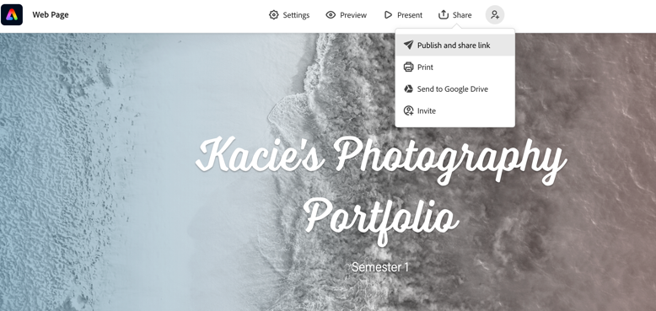
Go to the share button, click share and publish. Choose education as your type. Then create link.
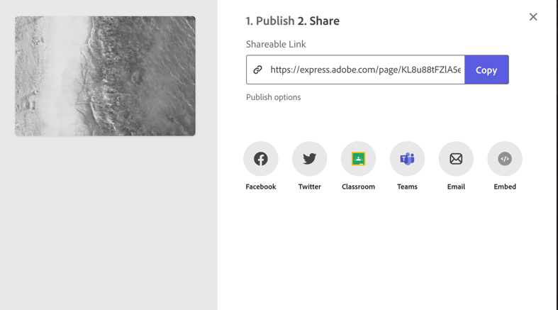
Once the link is created, click on the purple box that has the word copy in it. Then make a new blog post titled “Portfolio.”
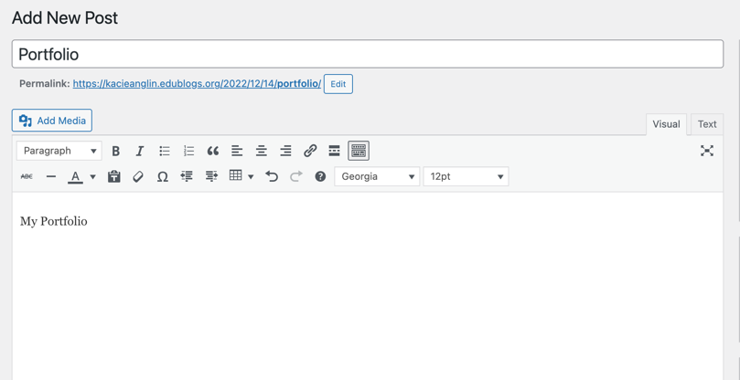
Add new post, titled Portfolio. In the blog post, add the words My Portfolio.

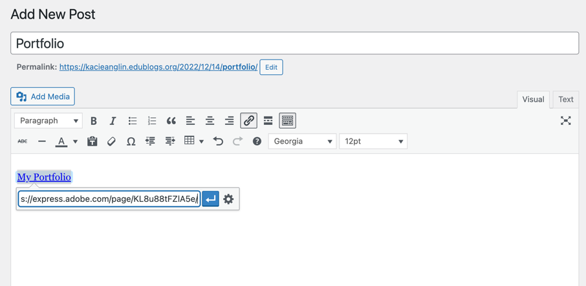
Highlight the word My Portfolio, then click on the chain link (circled above in Red). Paste the link in the box. Then click on the settings button (circled above in Green).

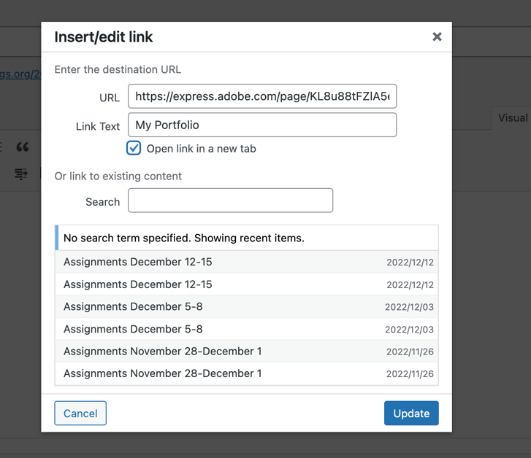

When you click on the settings button, this dialogue box opens. Click on the box next to the words that say “open link in a new tab” (circled in Purple).

